5D4N HO CHI MINH – PHAN THIET – MUI NE

DAY 1: HO CHI MINH – ARRIVAL ( D )
Upon arrival at Tan Son Nhat International Airport, our representative will meet and transfer to city center to visit The Hundreds Years Red Cathedral, Old Post Office, The People’s Committee Hall, French Opera House. Dinner at local restaurant, overnight at Ho Chi Minh.

Meals: 1 Dinner
Accommodation: Overnight in Saigon
The distance: Tan Son Nhat Airport – Saigon Center: 20km – 20 minutes for transfer.
DAY 2: HO CHI MINH – PHAN THIET ( B/L/D )
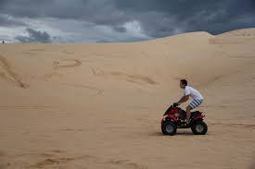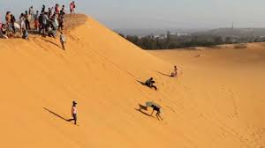
Sliding Sand in Mui Ne
After breakfast, proceed to the middle part of Vietnam, Binh Thuan Province – Phan Thiet City (198km from HCMC). Enjoying the scenery of farming field and the rural area with a very Vietnam’s characteristic. After lunch, proceed to the Cham Poshanu Tower and The White Sand Phan Thiet Beach, you can swim and enjoy the sunset. Dinner at local restaurant, overnight in Phan Thiet.

Meals: 1 Breakfast + 1 Lunch + 1 Dinner
Accommodation: Overnight in Phan Thiet
The distance: Saigon – Phan Thiet: 200km – 4 hours for transfer.
DAY 3: PHAN THIET – MUI NE (B/L/D)
After breakfast, proceed to visit Flying Yellow Sand Hills (enjoy the wonderful scenery – the Red Spring ), lunch at local restaurant, after lunch, proceed to Hon Rom, visit Red Sand Dunes. Dinner at local restaurant and overnight in Phan Thiet.

Meals: 1 Breakfast + 1 Lunch + 1 Dinner
Accommodation: Overnight in Phan Thiet

DAY 4: PHAN THIET - HO CHI MINH (B/L/D)
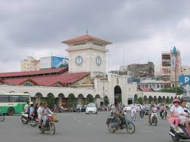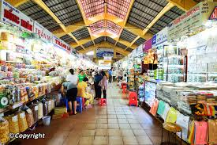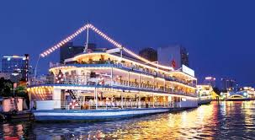
Ben Thanh Market Saigon River Cruise
After breakfast, free at leisure until transfer to lunch, after that back to Ho Chi Minh city, stop at Dong Khoi Str, Ben Thanh Market for shopping. Dinner will be served on Saigon River Cruise with show entertainment along the Saigon River at the end of the day. Overnight in Ho Chi Minh city.

Meals: 1 Breakfast + 1 Lunch + 1 Dinner
Accommodation: Overnight in Saigon
The distance: Phan Thiet - Saigon: 200km – 4 hours for transfer.

DAY 5: HO CHI MINH DEPARTURE (B)
After breakfast, free at leisure then transfer to Airport for flight home with sweet memories.

SEQUENCE OF ITINERARY SUBJECT TO LOCAL ARRANGEMENT

PRICE INCLUDE:
- Accommodation – as hotel in the list or similar – based on Twin/Double/Triple sharing
- Tour guide: English or Chinese speaking guide during the tour.
- Daily ABF and meals as mentioned in the program
- Shows and sightseeing in schedule.
- Transportation by private air-conditioner.
01 bottle ( 500 ml )of drinking water for each pax per day.
- Meals (Vietnamese Food & Chinese Food) as the tour code (B: Breakfast, L: Lunch, D: Dinner) 8-10 USD/meal/pax + One dinner on Saigon Cruise + 1 Buffet.

PRICE EXCLUDE:
- International / Domestic flight ticket & airport tax (if have)
- Personal expenses: Tel, Fax, Mini Bar, Laundry,etc.
- Personal travel insurance
- Compulsory Tip for local guide and driver (USD/pax/day)

Group Size | Tips in USD
2 – 4pax | 6
5-7pax | 5
8 - up | 3

- Additional Meal will be surcharge 10usd/pax/meal.
- Surcharge with other languages guide
- Surcharge at hotel case by case
  - Chinese New Year (TBA)
  - Gala Dinner on X’Mas (24, 25 Dec ) & New Year 31 Dec.

Hotel category  Hotel listed or Similar |  | All rates are next in USD/PAX  valid Jan- Dec, 2020
 |  | Tour by private car / bus with private guide
SAIGON | MUINE | 2 | 3-4 | 5-6 | 7-9 | 10-12 | 13-15 | 15+1 | 20+1 | 25+1 | 30+1 | SS
Le Duy 3*  Ambassador 3*  Alagon 3*  Bloom Saigon 3*  Aluna 3* | Mui Ne Boutique Resort 3*  Little Paris 3*  Tien Dat 3* | 396 | 341 | 291 | 263 | 258 | 246 | 241 | 231 | 226 | 216 | 100
Palace Saigon 4*  MuongThanh Saigon 4*  Athena 4* | Muong Thanh 4*  Novela 4* | 451 | 398 | 346 | 318 | 313 | 306 | 301 | 288 | 281 | 271 | 155

NOTE

The timing of sightseeing points shall be fixing by local operator due to traffic and weather conditions, however all points must cover unless amendment or cancellation make by clients themselves (Non-refundable for any cancellation that made by clients)

Tour and price are subject to change without notice or incase of deduct number of pax in quoted group.

Small deviations in the tour program are sometimes necessary, depending on weather, road conditions, flight schedules and room availability.

Supplement charge for room rate in peak dates depends on the hotel category used. Compulsory gala dinner on X’mas, New Year’s Eve & Lunar New Year’s Eve to be advised upon booking. Prices for group of 15 persons up in 5 stars hotels sometime requires to re-quote bases on the hotel policy

one (01) tour leader is given complimentary on twin sharing basis include breakfast (domestic air ticket is not applicable).

BUS

Group Size | Kind of Transportation
1-2 pax | 4 seater
3 pax | 7 seater
4-9pax | 16 seater
10-14 pax | 30 seater
15-22 pax | 35 seater
23 – 42 pax | 45 seater

CHILD POLICY

- Infant below 2 years old sharing same room with parents is free of charge.
- Child below 12 yrs old sharing same room with 1 ADL is charged for 90%.
- Child below 12 yrs old with extra bed and sharing same room with parents is charged for 65%.
- Child below 12 yrs old No extra bed & sharing same room with parents is charged for 55%

